Preaching Matters Week 7, Session 1:
How can we improve the style and tone of our communication?

[CAVEAT: Jonathan Edwards (great though fallen! preacher of the 18th century) had poor eyesight and tiny handwriting. When he preached he had to hold his notes so close to his face no one could see him. He broke all the rules of great oratory…his preaching led to a huge revival.]

Why does it matter?

Passion/conviction matters
‘One person with a belief is worth 99 who have only opinions’ (Ralph Waldo Emerson).

1 Thess 1:5 Our gospel came to you not simply with words but also with power, with the Holy Spirit and deep conviction.
1 Peter 4:11 If anyone speaks, they should do so as one who speaks the very words of God
Acts 20:31Remember that for three years I never stopped warning each of you night and day with tears

‘Though you give the holy things of God the highest praises in words, yet, if you do it coldly, you will seem by your manner to unsay what you said in the matter.’ (Richard Baxter, in The Reformed Pastor)

‘If I were asked “what in a Christian minister is the most essential quality for securing success in winning souls for Christ?” I should reply “earnestness”. And if I were asked a second or third time, I should not vary the answer.’ (Charles Spurgeon in Lectures to my Students)
What can we improve?
Voice:

How do we get that energy and connection?

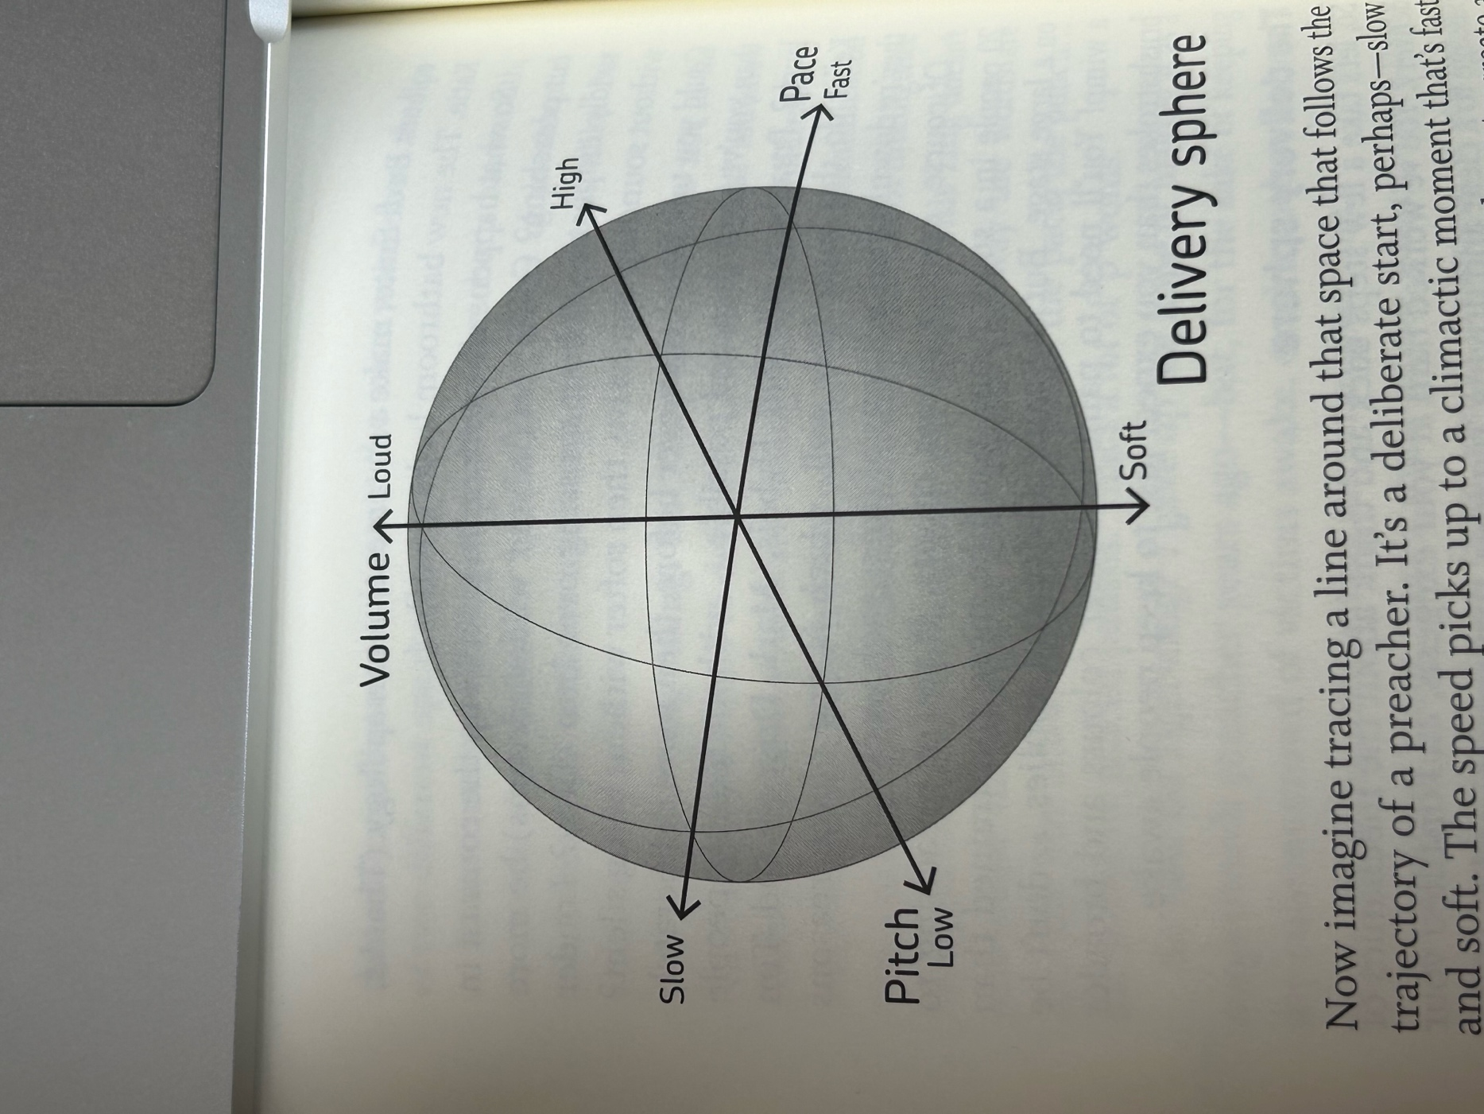

Imagine tracing a course around the ‘delivery sphere’ above…try to find the extremities in your range!
If you have a recording of a sermon you have preached perhaps listen back and plot the variety on this sphere…how might it look?
How fast did you talk? How slowly? What’s the pitch of your ‘conversational’ voice? Did it change? When you’re excited do you speak louder? How much louder?
Dull preaching tends to be monotone and or deathly slow.

Contrasts
The most agile (and often most engaging) speakers use contrast in their voice, often very sharply. Building to a loud crescendo, before slowing and quietening (for example). To what extent is this a feature of your preaching?

Clarity
If people can’t understand/hear you, they will give up listening. This isn’t about accents but about clarity. Being loud enough, being clear enough, and for important sections, being slow enough.

Know what you’re aiming for (how do you know what to emphasise?)

To varying degrees this will come naturally…but:

- (if using a full script): use UPPERCASE or bold to give your mind a cue for emphasis.
- If you use bullet points, consider writing out really important sections so you can be extra clear
- Know your sermon well enough to know its flow and where the emphasis needs to be; know which bits you can talk quickly through; which bits need a slower pace; where you might need a long pause etc.

Body Language

Peter Thomson (Persuading Aristotle p.118):

In his lectures on rhetoric at the Lyceum, Aristotle taught effective delivery as a key dimension of the art of persuasion. It is not just what you say, but how you say it that counts. Delivery was about a speaker's nonverbal communication: voice and body language. No matter how good your content is, if the message contained in your voice and body language doesn't fit the words you are saying, no-one will be convinced.
If you don't feel committed to what you say, you can't expect others to. For example, the speaker who delivers the opening line ‘I am really happy to be here today’, but who looks like they would prefer to be anywhere else in the world is certainly not sending the message in their words.

Thomson goes on to cite the trial of Lindy Chamberlain…

Key to body language: everything should be ‘saying’ the same thing. When the signals aren’t in tune listeners become confused as to which message to believe!

Consider:

- How am I standing in relation to the congregation? We don’t tend to trust those who don’t quite face us!
- Do I have any nervous ticks (normally most present in first 5 mins if we are nervous) – can I do something to help those? Eg grab on to a lectern!
- Eye contact: Look at people when you are preaching to them! Focus on those responding with enthusiasm. {NB. If you are making eye contact you will also read RESPONSE…there will be moments of conviction which need handling – perhaps pausing to pray etc.}
- Facial expression – it needs to match our words!
- Walking around/away from lectern? Can be good to show dynamism and direct (note free) communication. Can be distracting if it is too much or seems pointless.
- Hands: what are you doing with them? Mostly this will happen naturally – but probably good to avoid pointing! Also good to avoid absent mindedly playing with your clothes/hair/body.

So how can we improve in these things?

- When you write (whether in full or notes) write as you would speak not as you would write an essay!
- Practise your sermons. Literally practise them (somewhere private!) – crucial to practise out loud and as if you were delivering it. If you practice it 5 times out loud you will know it off by heart and could probably deliver it with no notes.
- Consider recording yourself practising. Listen/watch back purely listening for variation in pitch, pace, tone; body language.
- Invite specific feedback from a trusted friend.
- Keep practising.
- Listen to sermons of preachers you admire; watch good stand up/good Ted Talks etc. Learn from good communicators. Ask yourself why you find this person easy to listen to.

Tips on physical space:

- Where will your notes rest?
- Are your notes printed? If so, page numbers or in a book? Needs to be easy to turn pages.
- What amplification is there? If holding a mic, do you have enough hands free to also hold a bible/notes?
- If a lapel mic, is it securely fastened and in the right place?
- Where are you standing to deliver your talk? Can you see everyone?
- If there is a stage, stand in the middle not to one side – facing congregation squarely.
- How is the lighting? Dim lighting may be harder to concentrate. Can you see your notes?
- Glass of water for dry mouth
- Clothing – something (appropriate to context) you feel confident in and which won’t distract listeners (eg dodgy slogans on t-shirt!).

Questions for Discussion:

Martyn Lloyd-Jones (great preacher of the 20th cent) said preachers should preach with their whole personality, and with authority, freedom, seriousness, liveliness, zeal, warmth, urgency, persuasiveness, pathos or emotion, and power.

Which of those are your strongest qualities and which do you feel weaker in?
How could you shape your preaching to take advantage of those gifts?
How can you develop your weaker areas?

Is there one tip you might put into practice next time?!

